Họ và tên: Cao Xuân Mai
MSSV: 1150070028
Số Máy 18
LAB 2
Luyện tập
Xây dựng ứng dụng Truyện Cười (P1)

I. Tạo dự án Android Studio
1) File → New → New Project → Empty Views Activity.

II. Cấu hình màu & theme (MaterialComponents, NoActionBar)
Mở res/values/colors.xml thêm các màu:
<?xml version="1.0" encoding="utf-8"?>
<resources>
<color name="purple_200">#FFBB86FC</color>
<color name="purple_500">#FF6200EE</color>
<color name="purple_700">#FF3700B3</color>
<color name="teal_200">#FF03DAC5</color>
<color name="teal_700">#FF018786</color>
<color name="black">#FF000000</color>
<color name="white">#FFFFFFFF</color>
<color name="greenMid">#478942</color>
<color name="greenLight">#62BC5B</color>
<color name="greenSuperLight">#EFFFEE</color>
</resources>
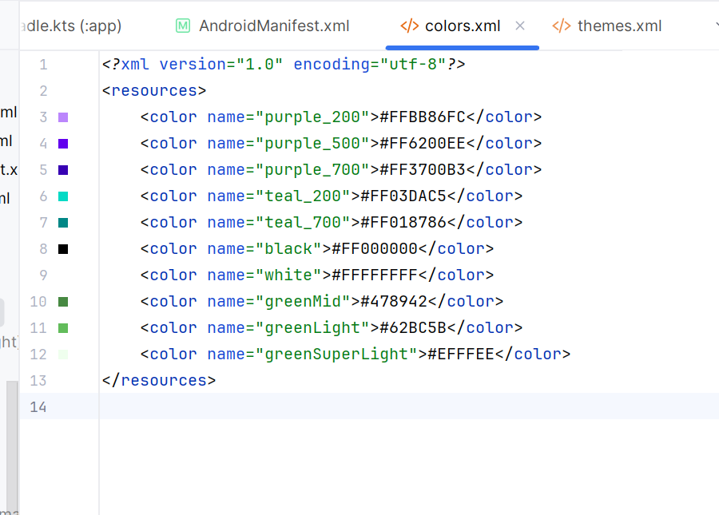
Mở res/values/themes.xml cấu hình Theme.MaterialComponents.DayNight.NoActionBar:
<?xml version="1.0" encoding="utf-8"?>
<resources xmlns:tools="http://schemas.android.com/tools">
<style name="Theme.Demo" parent="Theme.MaterialComponents.DayNight.NoActionBar">
<item name="colorPrimary">@color/purple_500</item>
<item name="colorPrimaryVariant">@color/purple_700</item>
<item name="colorOnPrimary">@color/white</item>
<item name="colorSecondary">@color/teal_200</item>
<item name="colorSecondaryVariant">@color/teal_700</item>
<item name="colorOnSecondary">@color/black</item>
<item name="android:statusBarColor" tools:targetApi="l">?attr/colorPrimaryVariant</item>
</style>
</resources>
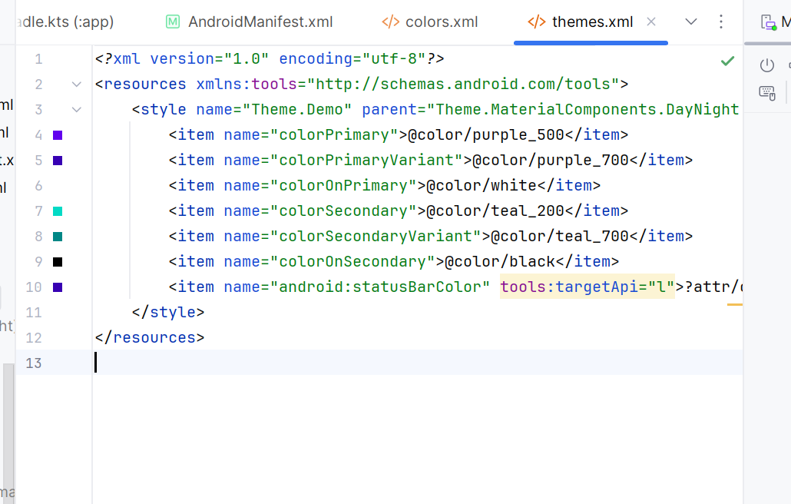

III. Khai báo đa ngôn ngữ (strings.xml)
A) res/values/strings.xml (tiếng Anh)
<?xml version="1.0" encoding="utf-8"?>
<resources>
<string name="app_name">TruyenCuoi</string>
<!-- Topics -->
<string name="txt_topics">Topics</string>
<string name="topic_family">Family</string>
<string name="topic_school">School</string>
<string name="topic_work">Work</string>
<string name="topic_misc">Misc</string>
<string name="txt_stories_of">Stories of %1$s</string>
<!-- Buttons -->
<string name="btn_prev">Previous</string>
<string name="btn_next">Next</string>
<!-- Sample stories -->
<string name="s1_title">Dad’s Logic</string>
<string name="s1_content">When I asked dad for money, he said: If money grew on trees...</string>
<string name="s2_title">Mom’s Secret</string>
<string name="s2_content">Mom said she had a secret recipe...</string>
<string name="s3_title">Exam Strategy</string>
<string name="s3_content">Teacher: Why are you looking at your watch...</string>
<string name="s4_title">Office Humor</string>
<string name="s4_content">Boss: Do you believe in life after work?</string>
<string name="s5_title">Random Joke</string>
<string name="s5_content">I told my phone I lost my sense of humor...</string>
<!-- Keys used by layouts to tránh lỗi resource linking -->
<string name="txt_story1">Funny story #1</string>
<string name="txt_story2">Funny story #2</string>
<string name="txt_name">Rabbit</string>
<string name="txt_desc">Rabbits are small mammals with long ears.</string>
</resources>
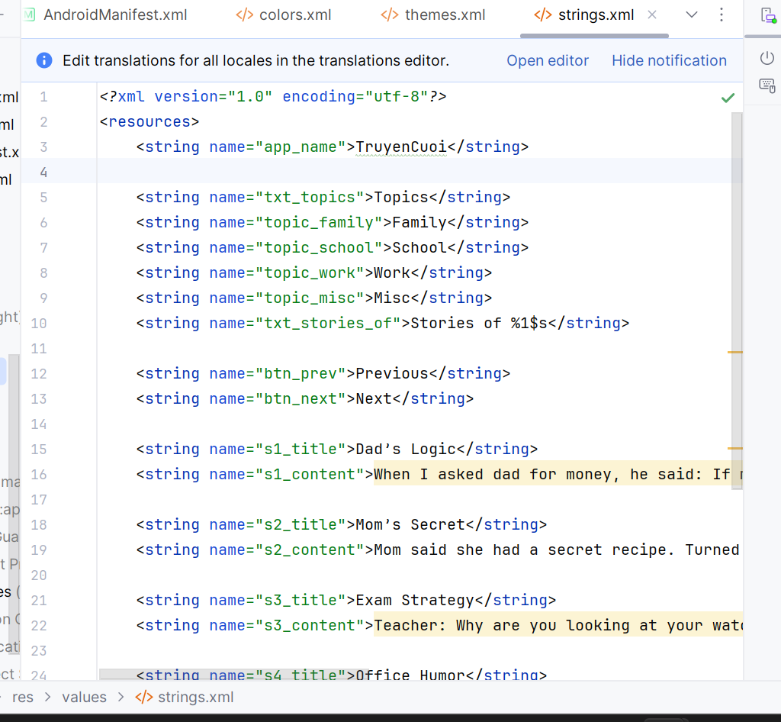
B) Tạo thư mục res/values-vi-rVN/strings.xml (tiếng Việt):
<?xml version="1.0" encoding="utf-8"?>
<resources>
<string name="app_name">Truyện Cười</string>
<!-- Topics -->
<string name="txt_topics">Chủ đề</string>
<string name="topic_family">Gia đình</string>
<string name="topic_school">Trường lớp</string>
<string name="topic_work">Công việc</string>
<string name="topic_misc">Tổng hợp</string>
<string name="txt_stories_of">Truyện của %1$s</string>
<!-- Buttons -->
<string name="btn_prev">Trước</string>
<string name="btn_next">Sau</string>
<!-- Sample stories -->
<string name="s1_title">Logic của ba</string>
<string name="s1_content">Khi xin tiền, ba bảo: Nếu tiền mọc trên cây...</string>
<string name="s2_title">Bí kíp của mẹ</string>
<string name="s2_content">Mẹ nói có bí kíp nấu ăn...</string>
<string name="s3_title">Chiến thuật thi cử</string>
<string name="s3_content">Cô: Sao em nhìn đồng hồ khi làm bài?</string>
<string name="s4_title">Chuyện công sở</string>
<string name="s4_content">Sếp: Em có tin vào cuộc sống sau giờ làm không?</string>
<string name="s5_title">Cười ngẫu hứng</string>
<string name="s5_content">Tôi nói điện thoại là tôi mất khiếu hài hước...</string>
<!-- Keys used by layouts -->
<string name="txt_story1">Truyện cười số 1</string>
<string name="txt_story2">Truyện cười số 2</string>
<string name="txt_name">Thỏ</string>
<string name="txt_desc">Thỏ là động vật có vú nhỏ với tai dài.</string>
</resources>
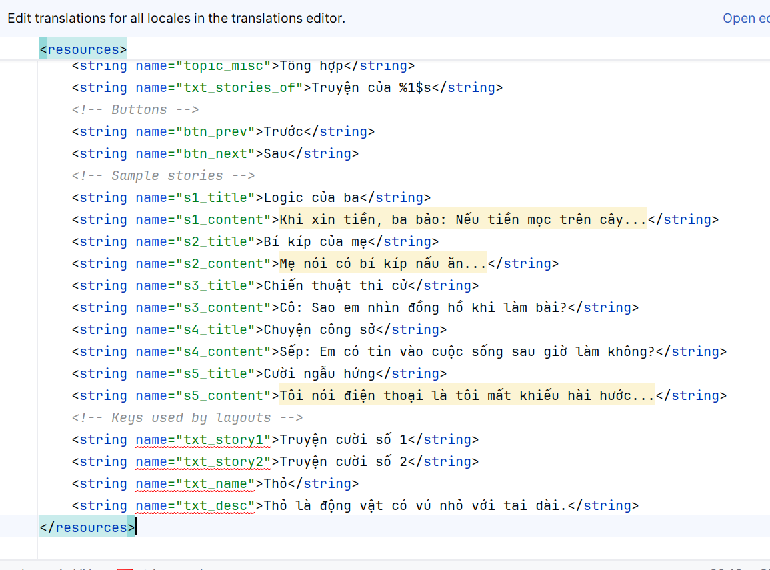

IV. Giao diện & Điều hướng (Layouts)
1) res/layout/activity_main.xml (container cho Fragment)
<?xml version="1.0" encoding="utf-8"?>
<LinearLayout xmlns:android="http://schemas.android.com/apk/res/android"
android:id="@+id/ln_main"
android:layout_width="match_parent"
android:layout_height="match_parent"
android:orientation="horizontal"/>
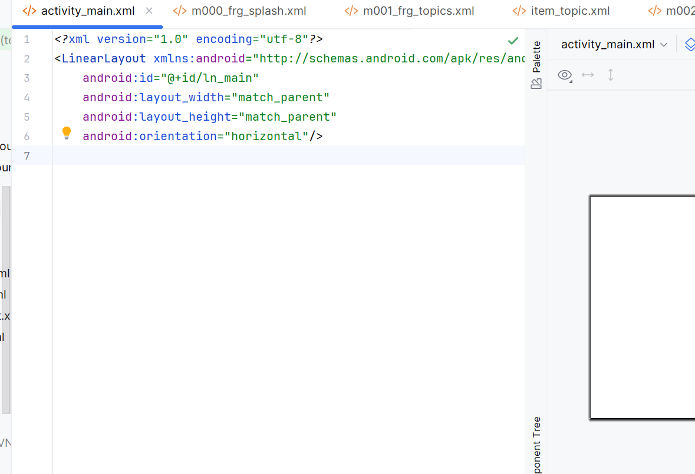
2) res/layout/m000_frg_splash.xml
<?xml version="1.0" encoding="utf-8"?>
<FrameLayout xmlns:android="http://schemas.android.com/apk/res/android"
android:layout_width="match_parent"
android:layout_height="match_parent"
android:background="@color/greenMid">
<ImageView
android:layout_width="200dp"
android:layout_height="100dp"
android:layout_gravity="center"
android:src="@drawable/ic_splash" />
</FrameLayout>
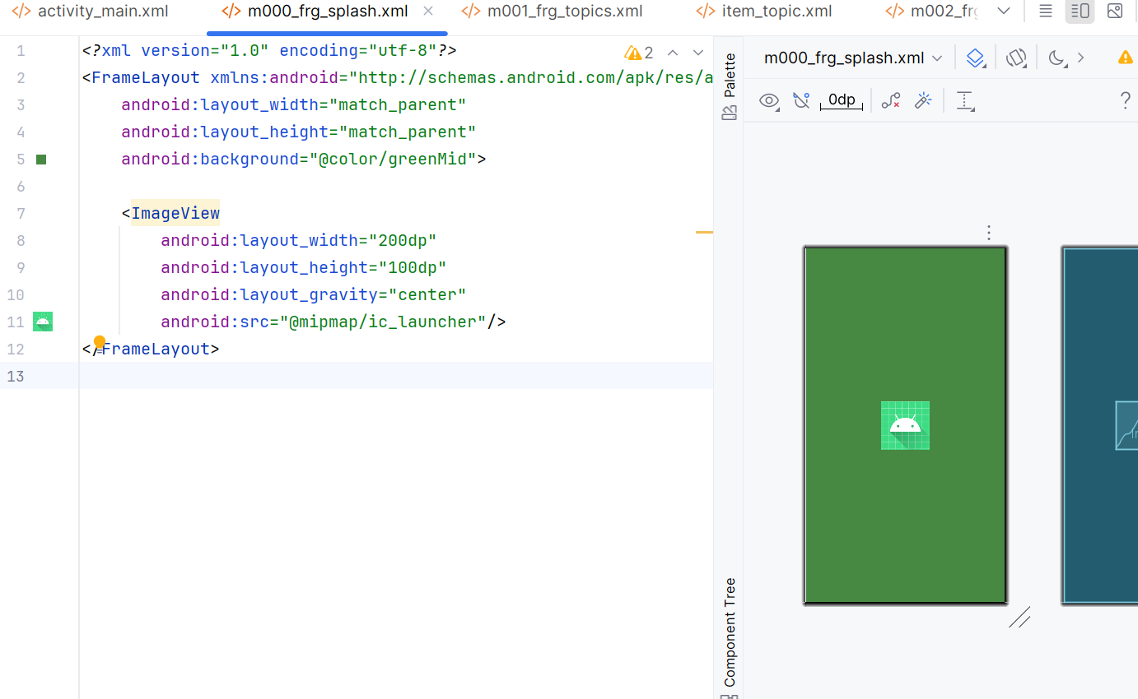
3) res/layout/m001_frg_topics.xml + res/layout/item_topic.xml
<?xml version="1.0" encoding="utf-8"?>
<!-- m001_frg_topics.xml -->
<LinearLayout xmlns:android="http://schemas.android.com/apk/res/android"
android:layout_width="match_parent"
android:layout_height="match_parent"
android:orientation="vertical"
android:background="@color/greenSuperLight"
android:padding="16dp">
<TextView
android:id="@+id/tv_title"
android:layout_width="match_parent"
android:layout_height="wrap_content"
android:text="@string/txt_topics"
android:textSize="22sp"
android:textStyle="bold"
android:textColor="@color/greenMid"/>
<androidx.recyclerview.widget.RecyclerView
android:id="@+id/rv_topics"
android:layout_width="match_parent"
android:layout_height="match_parent"
android:paddingTop="8dp"/>
</LinearLayout>
<!-- item_topic.xml -->
<LinearLayout xmlns:android="http://schemas.android.com/apk/res/android"
android:layout_width="match_parent"
android:layout_height="wrap_content"
android:padding="8dp">
<TextView
android:id="@+id/tv_topic"
android:layout_width="match_parent"
android:layout_height="wrap_content"
android:background="@drawable/bg_radius"
android:text="Gia đình"
android:textColor="@android:color/white"
android:textSize="18sp"
android:paddingHorizontal="16dp"
android:paddingVertical="10dp"/>
</LinearLayout>
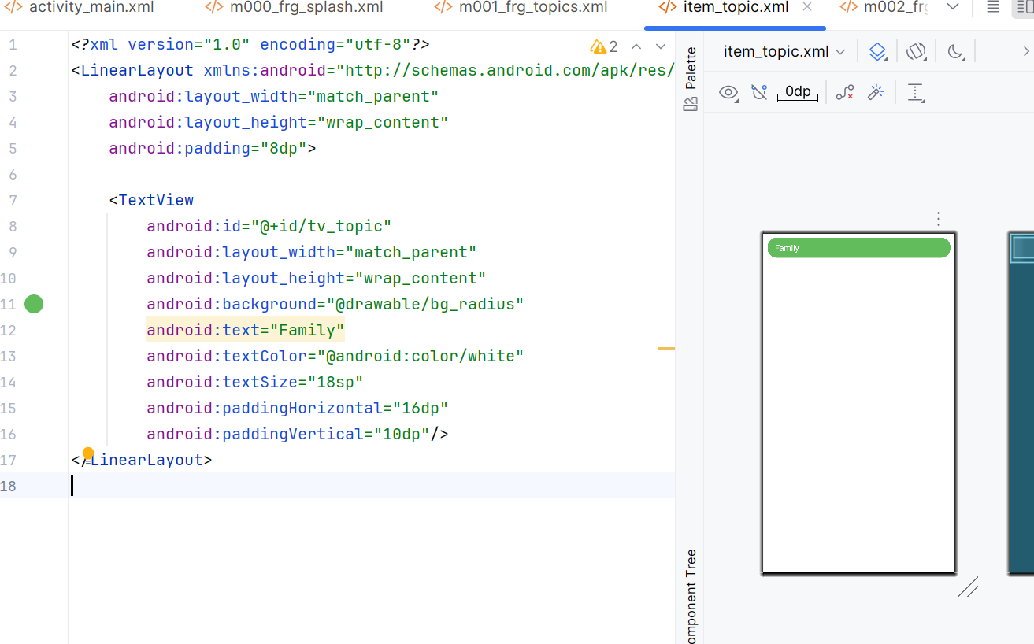
4) res/layout/m002_frg_story_list.xml + res/layout/item_story.xml
<?xml version="1.0" encoding="utf-8"?>
<!-- m002_frg_story_list.xml -->
<LinearLayout xmlns:android="http://schemas.android.com/apk/res/android"
android:layout_width="match_parent"
android:layout_height="match_parent"
android:orientation="vertical"
android:background="@color/greenSuperLight"
android:padding="16dp">
<TextView
android:id="@+id/tv_topic_header"
android:layout_width="match_parent"
android:layout_height="wrap_content"
android:text="Topic"
android:textStyle="bold"
android:textSize="20sp"
android:textColor="@color/greenMid"
android:paddingBottom="8dp"/>
<androidx.recyclerview.widget.RecyclerView
android:id="@+id/rv_stories"
android:layout_width="match_parent"
android:layout_height="match_parent"/>
</LinearLayout>
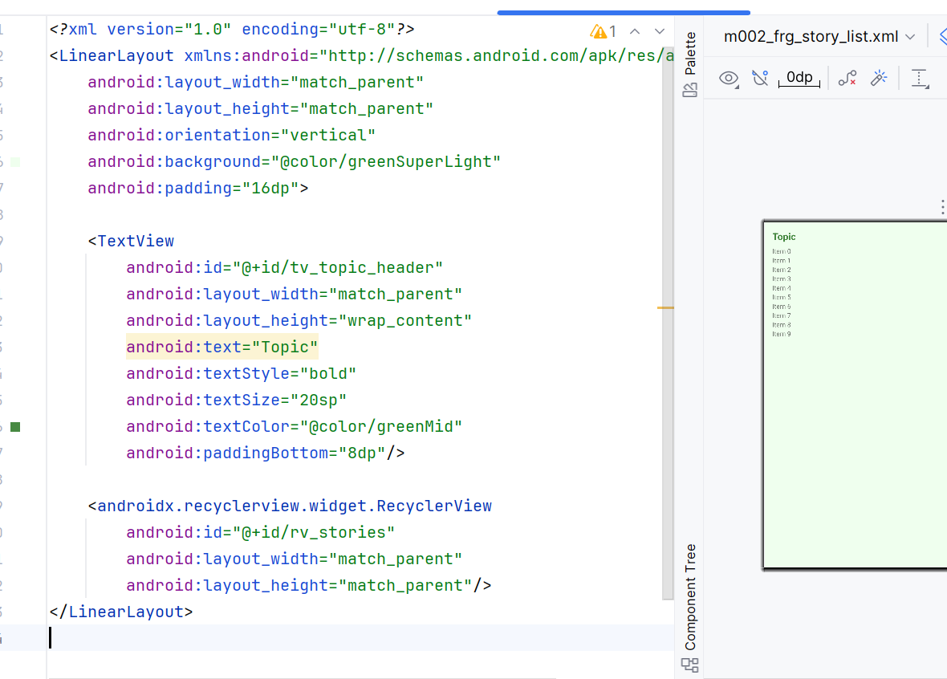
<!-- item_story.xml -->
<LinearLayout xmlns:android="http://schemas.android.com/apk/res/android"
android:layout_width="match_parent"
android:layout_height="wrap_content"
android:padding="12dp"
android:background="@android:color/white"
android:orientation="vertical"
android:layout_marginBottom="8dp">
<TextView
android:id="@+id/tv_story_title"
android:layout_width="match_parent"
android:layout_height="wrap_content"
android:text="Tiêu đề"
android:textSize="18sp"
android:textStyle="bold"/>
<TextView
android:id="@+id/tv_story_preview"
android:layout_width="match_parent"
android:layout_height="wrap_content"
android:text="Đoạn mở đầu..."
android:maxLines="2"
android:ellipsize="end"/>
</LinearLayout>
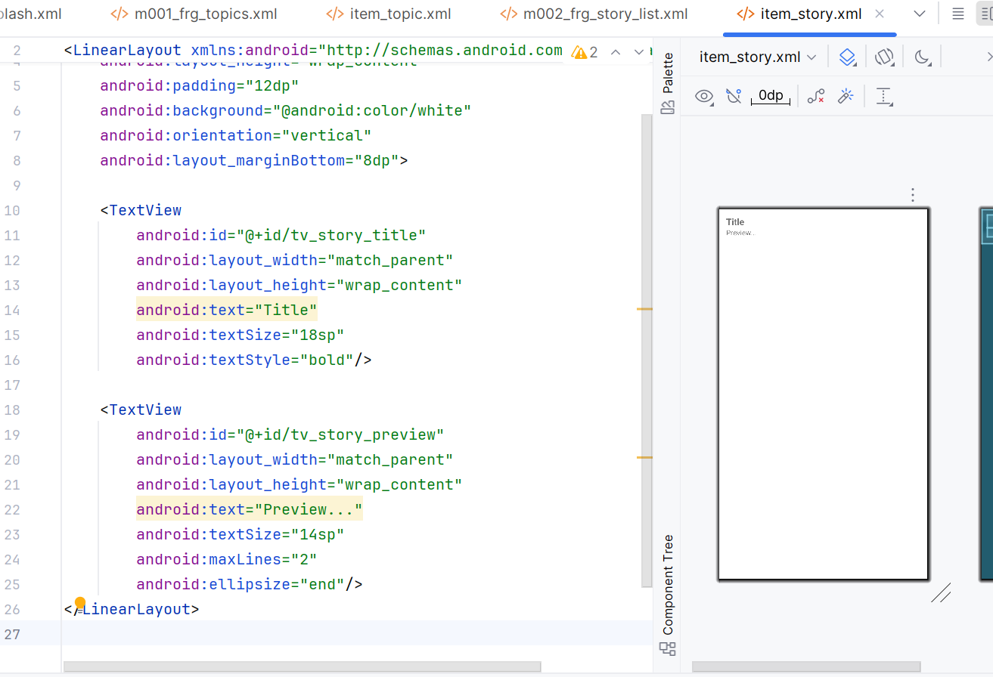
5) res/layout/m003_frg_detail.xml
<?xml version="1.0" encoding="utf-8"?>
<LinearLayout xmlns:android="http://schemas.android.com/apk/res/android"
android:layout_width="match_parent"
android:layout_height="match_parent"
android:orientation="vertical"
android:padding="16dp"
android:background="@android:color/white">
<TextView
android:id="@+id/tv_story_title"
android:layout_width="match_parent"
android:layout_height="wrap_content"
android:text="Tiêu đề"
android:textStyle="bold"
android:textSize="20sp"
android:textColor="@color/greenMid"
android:paddingBottom="8dp"/>
<ScrollView
android:layout_width="match_parent"
android:layout_height="0dp"
android:layout_weight="1">
<TextView
android:id="@+id/tv_story_content"
android:layout_width="match_parent"
android:layout_height="wrap_content"
android:text="Nội dung truyện..."
android:textSize="16sp"
android:lineSpacingExtra="4dp"/>
</ScrollView>
<LinearLayout
android:layout_width="match_parent"
android:layout_height="wrap_content"
android:orientation="horizontal"
android:paddingTop="8dp">
<TextView
android:id="@+id/btn_prev"
android:layout_width="0dp"
android:layout_height="48dp"
android:layout_weight="1"
android:gravity="center"
android:text="@string/btn_prev"
android:background="@drawable/bg_radius"
android:textColor="@android:color/white"/>
<View android:layout_width="12dp" android:layout_height="1dp"/>
<TextView
android:id="@+id/btn_next"
android:layout_width="0dp"
android:layout_height="48dp"
android:layout_weight="1"
android:gravity="center"
android:text="@string/btn_next"
android:background="@drawable/bg_radius"
android:textColor="@android:color/white"/>
</LinearLayout>
</LinearLayout>
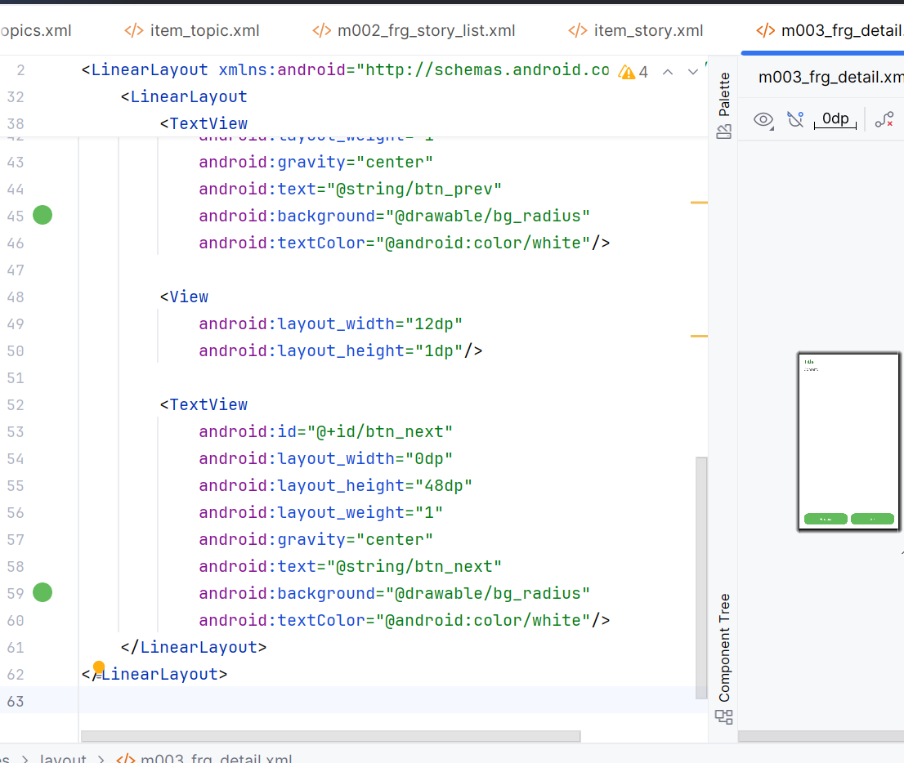
Drawable bo góc: res/drawable/bg_radius.xml
<?xml version="1.0" encoding="utf-8"?>
<shape xmlns:android="http://schemas.android.com/apk/res/android">
<corners android:radius="20dp"/>
<solid android:color="@color/greenLight"/>
</shape>

V. Java code (package com.example.mailab2)
1) MainActivity.java
package com.example.mailab2;
import android.os.Bundle;
import androidx.annotation.NonNull;
import androidx.appcompat.app.AppCompatActivity;
import androidx.fragment.app.Fragment;
import androidx.fragment.app.FragmentTransaction;
import java.util.ArrayList;
public class MainActivity extends AppCompatActivity {
private ArrayList<StoryEntity> stories;
private StoryEntity currentStory;
@Override protected void onCreate(Bundle savedInstanceState) {
super.onCreate(savedInstanceState);
setContentView(R.layout.activity_main);
showFrg(new M000SplashFrg(), false);
}
public void showFrg(@NonNull Fragment frg, boolean addToBackStack) {
FragmentTransaction tx = getSupportFragmentManager()
.beginTransaction()
.replace(R.id.ln_main, frg, frg.getClass().getSimpleName());
if (addToBackStack) tx.addToBackStack(frg.getClass().getSimpleName());
tx.commit();
}
public void gotoM001Screen() { showFrg(new M001TopicListFrg(), false); }
public void gotoM002Screen(String topicName) {
M002StoryListFrg frg = M002StoryListFrg.newInstance(topicName);
showFrg(frg, true);
}
public void gotoM003Screen(ArrayList<StoryEntity> listStory, StoryEntity story) {
this.stories = listStory;
this.currentStory = story;
M003StoryDetailFrg frg = M003StoryDetailFrg.newInstance(listStory, story);
showFrg(frg, true);
}
public void openStoryAt(int index) {
if (stories == null || index < 0 || index >= stories.size()) return;
currentStory = stories.get(index);
M003StoryDetailFrg frg = M003StoryDetailFrg.newInstance(stories, currentStory);
showFrg(frg, false);
}
}
2) M000SplashFrg.java
package com.example.mailab2;
import android.app.Activity;
import android.os.Bundle;
import android.os.Handler;
import android.os.Looper;
import android.view.LayoutInflater;
import android.view.View;
import android.view.ViewGroup;
import androidx.annotation.NonNull;
import androidx.annotation.Nullable;
import androidx.fragment.app.Fragment;
public class M000SplashFrg extends Fragment {
@Nullable
@Override
public View onCreateView(@NonNull LayoutInflater inflater, @Nullable ViewGroup container, @Nullable Bundle savedInstanceState) {
return inflater.inflate(R.layout.m000_frg_splash, container, false);
}
@Override
public void onViewCreated(@NonNull View view, @Nullable Bundle savedInstanceState) {
super.onViewCreated(view, savedInstanceState);
new Handler(Looper.getMainLooper()).postDelayed(this::gotoM001Screen, 1500);
}
private void gotoM001Screen() {
Activity act = getActivity();
if (act instanceof MainActivity) ((MainActivity) act).gotoM001Screen();
}
}
3) Entity & Repo – StoryEntity.java, StoryRepo.java
package com.example.mailab2;
import android.os.Parcel;
import android.os.Parcelable;
public class StoryEntity implements Parcelable {
public int id; public String title; public String content;
public StoryEntity(int id, String title, String content){ this.id=id; this.title=title; this.content=content; }
protected StoryEntity(Parcel in){ id=in.readInt(); title=in.readString(); content=in.readString(); }
public static final Creator<StoryEntity> CREATOR=new Creator<StoryEntity>(){
public StoryEntity createFromParcel(Parcel in){ return new StoryEntity(in); }
public StoryEntity[] newArray(int size){ return new StoryEntity[size]; }
};
public int describeContents(){ return 0; }
public void writeToParcel(Parcel dest,int flags){ dest.writeInt(id); dest.writeString(title); dest.writeString(content); }
}
package com.example.mailab2;
import android.content.Context;
import java.util.ArrayList;
public class StoryRepo {
public static ArrayList<StoryEntity> getStoriesByTopic(Context ctx, String topic){
ArrayList<StoryEntity> ls = new ArrayList<>();
if (topic.equals(ctx.getString(R.string.topic_family))) {
ls.add(new StoryEntity(1, ctx.getString(R.string.s1_title), ctx.getString(R.string.s1_content)));
ls.add(new StoryEntity(2, ctx.getString(R.string.s2_title), ctx.getString(R.string.s2_content)));
} else if (topic.equals(ctx.getString(R.string.topic_school))) {
ls.add(new StoryEntity(3, ctx.getString(R.string.s3_title), ctx.getString(R.string.s3_content)));
} else if (topic.equals(ctx.getString(R.string.topic_work))) {
ls.add(new StoryEntity(4, ctx.getString(R.string.s4_title), ctx.getString(R.string.s4_content)));
} else {
ls.add(new StoryEntity(5, ctx.getString(R.string.s5_title), ctx.getString(R.string.s5_content)));
}
return ls;
}
}
4) Topic list – M001TopicListFrg.java + TopicAdapter.java
package com.example.mailab2;
import android.os.Bundle;
import android.view.LayoutInflater;
import android.view.View;
import android.view.ViewGroup;
import androidx.annotation.NonNull;
import androidx.annotation.Nullable;
import androidx.fragment.app.Fragment;
import androidx.recyclerview.widget.DividerItemDecoration;
import androidx.recyclerview.widget.LinearLayoutManager;
import androidx.recyclerview.widget.RecyclerView;
import java.util.Arrays;
import java.util.List;
public class M001TopicListFrg extends Fragment {
@Nullable
@Override
public View onCreateView(@NonNull LayoutInflater inflater, @Nullable ViewGroup container, @Nullable Bundle savedInstanceState) {
return inflater.inflate(R.layout.m001_frg_topics, container, false);
}
@Override
public void onViewCreated(@NonNull View v, @Nullable Bundle s) {
super.onViewCreated(v, s);
RecyclerView rv = v.findViewById(R.id.rv_topics);
rv.setLayoutManager(new LinearLayoutManager(getContext()));
rv.addItemDecoration(new DividerItemDecoration(getContext(), RecyclerView.VERTICAL));
List<String> topics = Arrays.asList(
getString(R.string.topic_family),
getString(R.string.topic_school),
getString(R.string.topic_work),
getString(R.string.topic_misc)
);
rv.setAdapter(new TopicAdapter(topics, topic -> ((MainActivity) requireActivity()).gotoM002Screen(topic)));
}
}
package com.example.mailab2;
import android.view.LayoutInflater;
import android.view.View;
import android.view.ViewGroup;
import android.widget.TextView;
import androidx.annotation.NonNull;
import androidx.recyclerview.widget.RecyclerView;
import java.util.List;
public class TopicAdapter extends RecyclerView.Adapter<TopicAdapter.VH> {
public interface OnTopicClick { void onClick(String topic); }
private final List<String> data; private final OnTopicClick listener;
public TopicAdapter(List<String> data, OnTopicClick listener){ this.data=data; this.listener=listener; }
@NonNull @Override public VH onCreateViewHolder(@NonNull ViewGroup parent,int viewType){
View v= LayoutInflater.from(parent.getContext()).inflate(R.layout.item_topic, parent,false);
return new VH(v);
}
@Override public void onBindViewHolder(@NonNull VH h,int pos){
String topic=data.get(pos); h.tv.setText(topic);
h.itemView.setOnClickListener(v -> { if (listener!=null) listener.onClick(topic); });
}
@Override public int getItemCount(){ return data.size(); }
static class VH extends RecyclerView.ViewHolder{
TextView tv; VH(@NonNull View itemView){ super(itemView); tv=itemView.findViewById(R.id.tv_topic); }
}
}
5) Story list – M002StoryListFrg.java + StoryAdapter.java
package com.example.mailab2;
import android.os.Bundle;
import android.view.LayoutInflater;
import android.view.View;
import android.view.ViewGroup;
import android.widget.TextView;
import androidx.annotation.NonNull;
import androidx.annotation.Nullable;
import androidx.fragment.app.Fragment;
import androidx.recyclerview.widget.LinearLayoutManager;
import androidx.recyclerview.widget.RecyclerView;
import java.util.ArrayList;
public class M002StoryListFrg extends Fragment {
private static final String ARG_TOPIC = "arg_topic";
public static M002StoryListFrg newInstance(String topic){
Bundle b=new Bundle(); b.putString(ARG_TOPIC, topic);
M002StoryListFrg f=new M002StoryListFrg(); f.setArguments(b); return f;
}
@Nullable @Override
public View onCreateView(@NonNull LayoutInflater inflater,@Nullable ViewGroup container,@Nullable Bundle s){
return inflater.inflate(R.layout.m002_frg_story_list, container,false);
}
@Override public void onViewCreated(@NonNull View v,@Nullable Bundle s){
super.onViewCreated(v,s);
String topic=getArguments()!=null?getArguments().getString(ARG_TOPIC):"";
((TextView)v.findViewById(R.id.tv_topic_header)).setText(getString(R.string.txt_stories_of, topic));
RecyclerView rv=v.findViewById(R.id.rv_stories);
rv.setLayoutManager(new LinearLayoutManager(getContext()));
ArrayList<StoryEntity> list=StoryRepo.getStoriesByTopic(getContext(), topic);
rv.setAdapter(new StoryAdapter(list,(story,pos)->((MainActivity)requireActivity()).gotoM003Screen(list, story)));
}
}
package com.example.mailab2;
import android.view.LayoutInflater;
import android.view.View;
import android.view.ViewGroup;
import android.widget.TextView;
import androidx.annotation.NonNull;
import androidx.recyclerview.widget.RecyclerView;
import java.util.ArrayList;
public class StoryAdapter extends RecyclerView.Adapter<StoryAdapter.VH> {
public interface OnStoryClick { void onClick(StoryEntity story,int position); }
private final ArrayList<StoryEntity> data; private final OnStoryClick listener;
public StoryAdapter(ArrayList<StoryEntity> data, OnStoryClick listener){ this.data=data; this.listener=listener; }
@NonNull @Override public VH onCreateViewHolder(@NonNull ViewGroup parent,int viewType){
View v= LayoutInflater.from(parent.getContext()).inflate(R.layout.item_story,parent,false);
return new VH(v);
}
@Override public void onBindViewHolder(@NonNull VH h,int pos){
StoryEntity s=data.get(pos);
h.tvTitle.setText(s.title);
String preview=s.content.length()>80?s.content.substring(0,80)+"...":s.content;
h.tvPreview.setText(preview);
h.itemView.setOnClickListener(v->{ if(listener!=null) listener.onClick(s,h.getBindingAdapterPosition()); });
}
@Override public int getItemCount(){ return data.size(); }
static class VH extends RecyclerView.ViewHolder{
TextView tvTitle,tvPreview; VH(@NonNull View itemView){
super(itemView); tvTitle=itemView.findViewById(R.id.tv_story_title); tvPreview=itemView.findViewById(R.id.tv_story_preview); }
}
}
6) Detail – M003StoryDetailFrg.java (vuốt trái/phải)
package com.example.mailab2;
import android.os.Bundle;
import android.view.GestureDetector;
import android.view.LayoutInflater;
import android.view.MotionEvent;
import android.view.View;
import android.view.ViewGroup;
import android.widget.TextView;
import androidx.annotation.NonNull;
import androidx.annotation.Nullable;
import androidx.fragment.app.Fragment;
import java.util.ArrayList;
public class M003StoryDetailFrg extends Fragment {
private static final String ARG_LIST = "arg_list";
private static final String ARG_CURR = "arg_curr";
private ArrayList<StoryEntity> list; private StoryEntity current; private int currentIndex;
public static M003StoryDetailFrg newInstance(ArrayList<StoryEntity> list, StoryEntity current){
Bundle b=new Bundle(); b.putParcelableArrayList(ARG_LIST, list); b.putParcelable(ARG_CURR, current);
M003StoryDetailFrg f=new M003StoryDetailFrg(); f.setArguments(b); return f;
}
@Nullable @Override public View onCreateView(@NonNull LayoutInflater inflater,@Nullable ViewGroup container,@Nullable Bundle s){
return inflater.inflate(R.layout.m003_frg_detail, container,false);
}
@Override public void onViewCreated(@NonNull View v,@Nullable Bundle s){
super.onViewCreated(v,s);
list=getArguments().getParcelableArrayList(ARG_LIST);
current=getArguments().getParcelable(ARG_CURR);
currentIndex=0; for(int i=0;i<list.size();i++) if(list.get(i).id==current.id){ currentIndex=i; break; }
TextView tvTitle=v.findViewById(R.id.tv_story_title);
TextView tvContent=v.findViewById(R.id.tv_story_content);
tvTitle.setText(current.title); tvContent.setText(current.content);
v.findViewById(R.id.btn_prev).setOnClickListener(view->goPrev());
v.findViewById(R.id.btn_next).setOnClickListener(view->goNext());
GestureDetector detector=new GestureDetector(getContext(), new GestureDetector.SimpleOnGestureListener(){
private static final int SWIPE_THRESHOLD=120, SWIPE_VELOCITY_THRESHOLD=120;
@Override public boolean onFling(MotionEvent e1, MotionEvent e2,float vX,float vY){
float dx=e2.getX()-e1.getX();
if (Math.abs(dx)>Math.abs(e2.getY()-e1.getY())){
if (Math.abs(dx)>SWIPE_THRESHOLD && Math.abs(vX)>SWIPE_VELOCITY_THRESHOLD){
if (dx<0) goNext(); else goPrev(); return true;
}
}
return false;
}
});
v.setOnTouchListener((vv,ev)->detector.onTouchEvent(ev));
}
private void goPrev(){ if(currentIndex<=0) return; currentIndex--; ((MainActivity)requireActivity()).openStoryAt(currentIndex); }
private void goNext(){ if(list==null) return; if(currentIndex>=list.size()-1) return; currentIndex++; ((MainActivity)requireActivity()).openStoryAt(currentIndex); }
}
LAB4
A. TẠO PROJECT MỚI
1. Mở Android Studio → New Project
2. Chọn Empty Views Activity
3. Đặt tên:
- Package name: com.example.lab4ui
- Language: Java
- Minimum SDK: API 24 (Android 7.0)
- Build configuration: Dùng Java 11
4. Bấm Finish
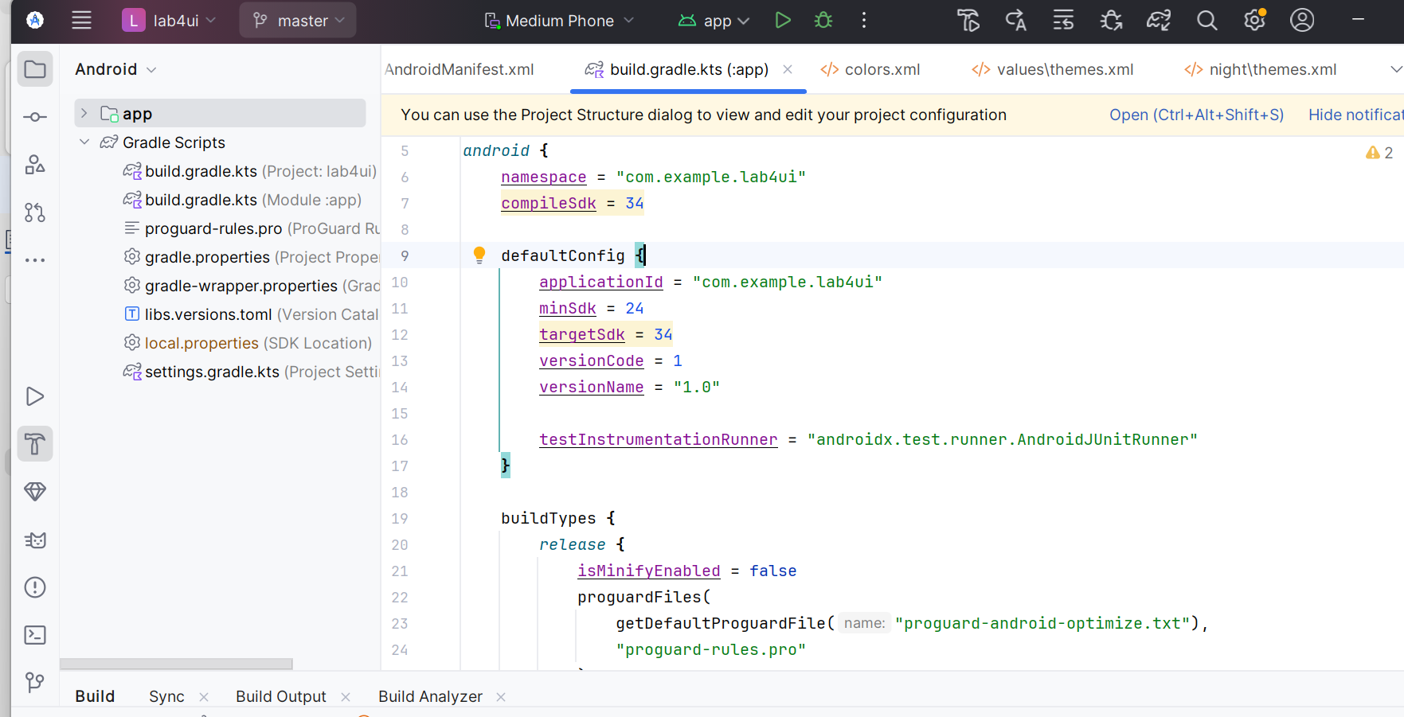
A1. TẮT ACTIONBAR
Mở file: res/values/themes.xml
<style name="Theme.Lab4UI" parent="Theme.Material3.Light.NoActionBar">
</style>
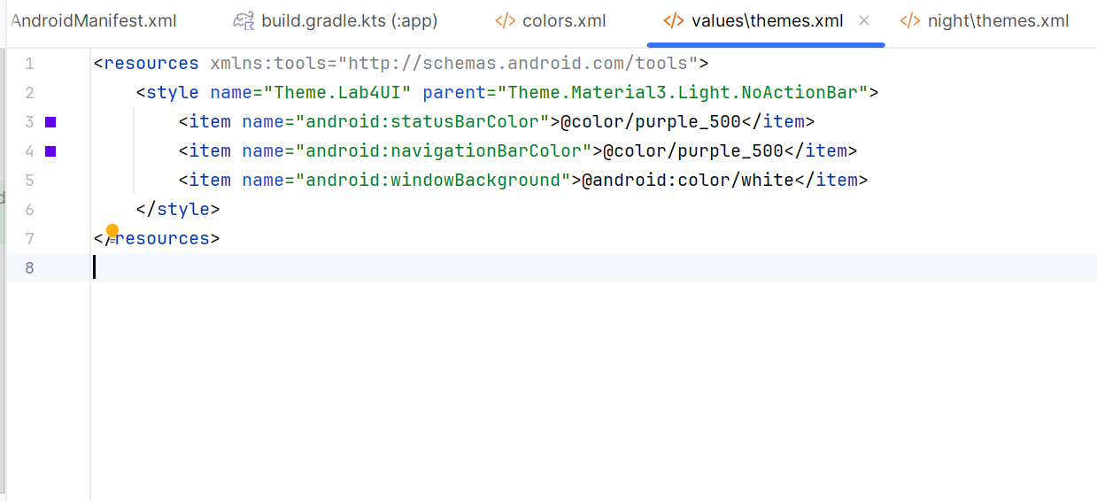
Rồi vào AndroidManifest.xml, sửa theme của ứng dụng:
<application
android:theme="@style/Theme.Lab4UI"
... >
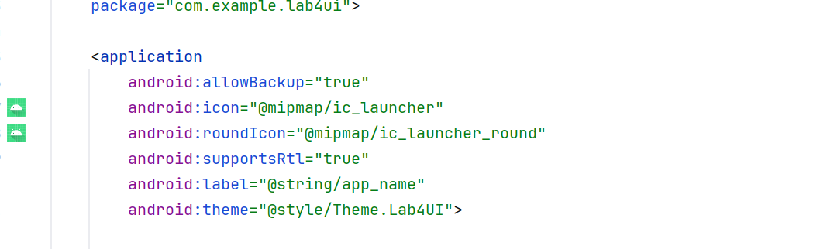
Giờ giao diện sẽ không còn thanh ActionBar mặc định nữa.
B. LUYỆN TẬP 1 – MÀN HÌNH LOGIN + TOAST XỊN
B1. THÊM MÀU & CHUỖI VĂN BẢN
res/values/colors.xml
<color name="black">#FF000000</color>
<color name="white">#FFFFFFFF</color>
<color name="gray">#EAE5E3</color>
<color name="orange">#FB8C00</color>
<color name="orangeMid">#F4511E</color>
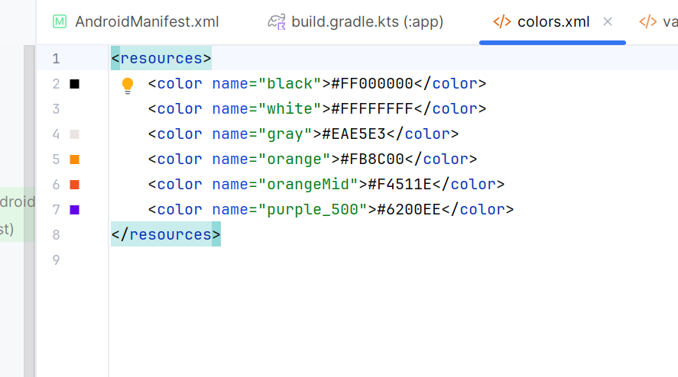
res/values/strings.xml

<string name="app_name">Lab4UI</string>
<string name="txt_login">Login</string>
<string name="hint_email">Email</string>
<string name="hint_password">Password</string>
<string name="txt_forgot_pass">Forgot password?</string>
<string name="txt_no_account">Don't have an account?</string>
<string name="txt_register">Register</string>
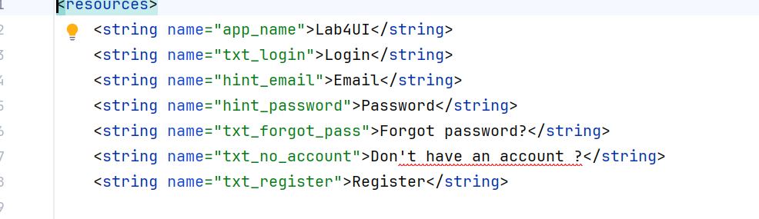
B2. TẠO HÌNH NỀN & BO GÓC
Tạo 3 file trong res/drawable/:
bg_rect.png
Dùng 1 ảnh nền mờ (có thể để trống hoặc dùng ảnh nhạt).
bg_radius.xml – Ô nhập liệu bo tròn
<?xml version="1.0" encoding="utf-8"?>
<layer-list xmlns:android="http://schemas.android.com/apk/res/android">
<item android:drawable="@drawable/bg_rect" />
<item android:bottom="3dp">
<shape>
<corners android:radius="20dp" />
<solid android:color="#ffffff" />
</shape>
</item>
</layer-list>

bg_login.xml – Nút Login đẹp

<?xml version="1.0" encoding="utf-8"?>
<layer-list xmlns:android="http://schemas.android.com/apk/res/android">
<item android:drawable="@drawable/bg_rect" />
<item android:bottom="3dp">
<shape>
<corners android:radius="20dp" />
<gradient
android:angle="180"
android:startColor="@color/orangeMid"
android:endColor="@color/orange"/>
</shape>
</item>
</layer-list>
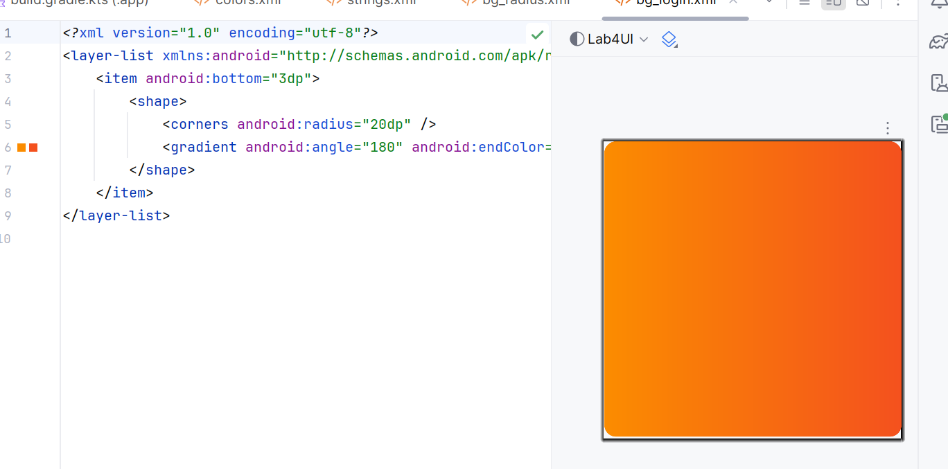
bg_top.xml – Phần đầu cong cong

<?xml version="1.0" encoding="utf-8"?>
<shape xmlns:android="http://schemas.android.com/apk/res/android">
<corners android:bottomLeftRadius="100dp" />
<gradient
android:angle="145"
android:startColor="@color/orangeMid"
android:endColor="@color/orange"/>
</shape>
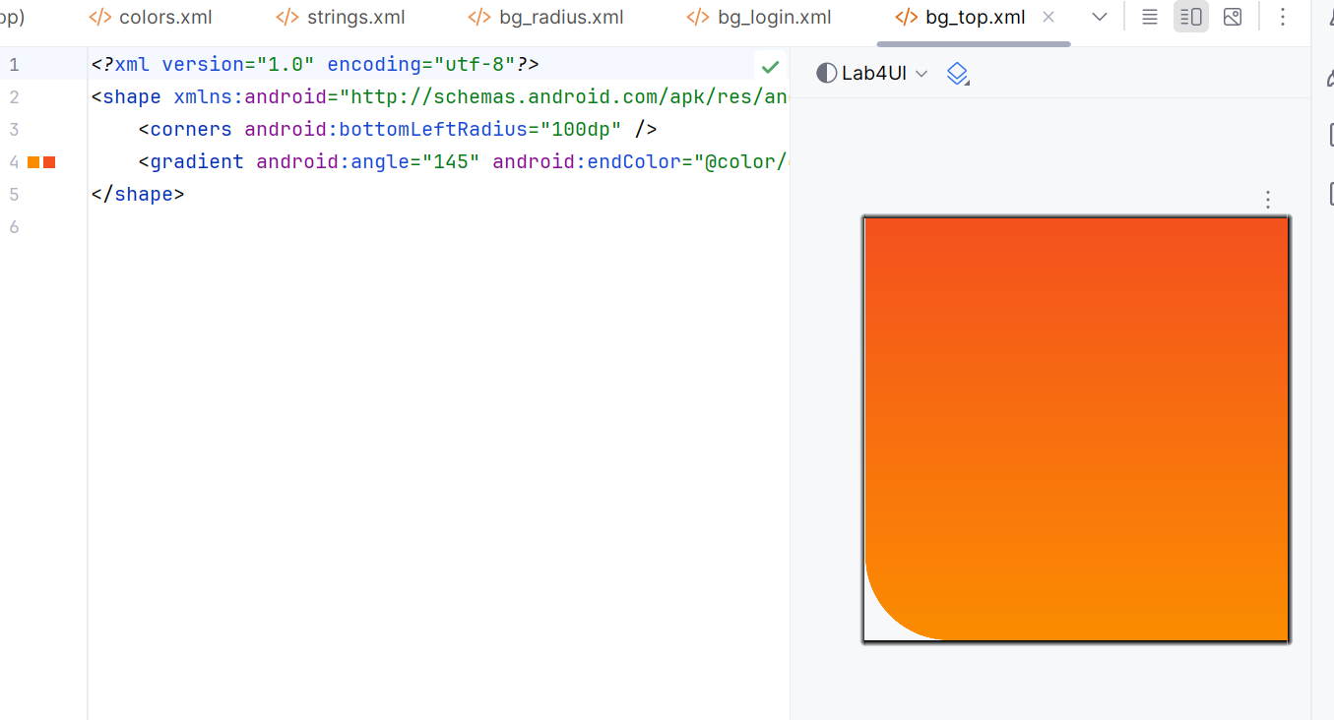
B3. THÊM ICON VECTOR
Vào Android Studio:
Right-click drawable → New → Vector Asset
→ Tìm:
- mail → Lưu thành ic_mail.xml
- vpn_key (hoặc key) → Lưu thành ic_key.xml
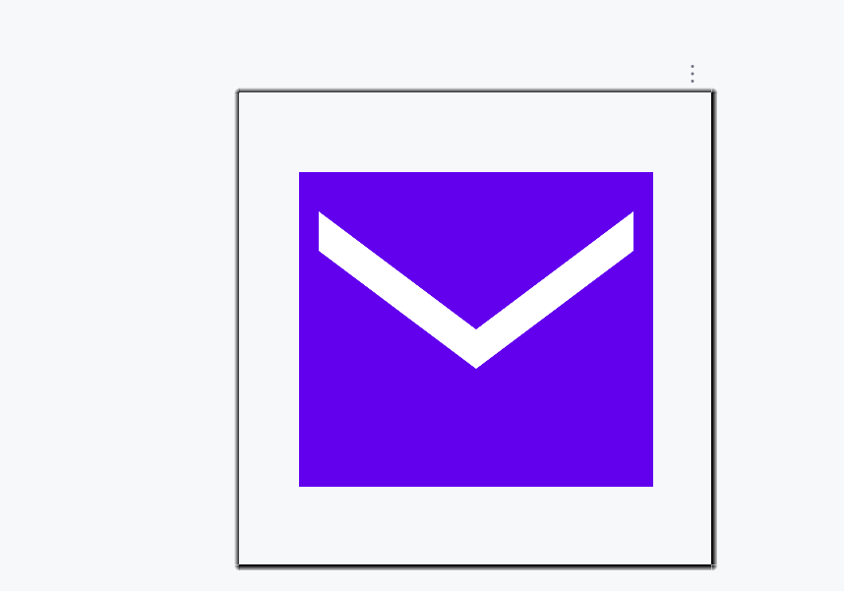
B4. THIẾT KẾ GIAO DIỆN LOGIN
Tạo file: res/layout/m001_act_login.xml

<?xml version="1.0" encoding="utf-8"?>
<LinearLayout xmlns:android="http://schemas.android.com/apk/res/android"
android:layout_width="match_parent"
android:layout_height="match_parent"
android:orientation="vertical"
android:background="@color/gray">

<FrameLayout
android:layout_width="match_parent"
android:layout_height="wrap_content">

<View
android:layout_width="match_parent"
android:layout_height="300dp"
android:background="@drawable/bg_top"/>

<TextView
android:layout_width="wrap_content"
android:layout_height="wrap_content"
android:layout_gravity="end"
android:layout_marginTop="220dp"
android:layout_marginEnd="30dp"
android:text="@string/txt_login"
android:textColor="@color/white"
android:textSize="20sp"/>
</FrameLayout>

<EditText
android:id="@+id/edtEmail"
android:layout_width="match_parent"
android:layout_height="50dp"
android:layout_marginHorizontal="30dp"
android:layout_marginTop="50dp"
android:layout_marginBottom="3dp"
android:background="@drawable/bg_radius"
android:drawableStart="@drawable/ic_mail"
android:drawablePadding="10dp"
android:hint="@string/hint_email"
android:padding="10dp"
android:inputType="textEmailAddress"
android:textSize="18sp"/>

<EditText
android:id="@+id/edtPass"
android:layout_width="match_parent"
android:layout_height="50dp"
android:layout_marginHorizontal="30dp"
android:layout_marginTop="20dp"
android:layout_marginBottom="3dp"
android:background="@drawable/bg_radius"
android:drawableStart="@drawable/ic_key"
android:drawablePadding="10dp"
android:hint="@string/hint_password"
android:padding="10dp"
android:inputType="textPassword"
android:textSize="18sp"/>

<TextView
android:layout_width="wrap_content"
android:layout_height="wrap_content"
android:layout_gravity="end"
android:layout_marginTop="10dp"
android:layout_marginEnd="30dp"
android:text="@string/txt_forgot_pass"
android:textColor="@color/black"
android:textSize="18sp"/>

<TextView
android:id="@+id/btnLogin"
android:layout_width="match_parent"
android:layout_height="50dp"
android:layout_marginHorizontal="30dp"
android:layout_marginTop="50dp"
android:background="@drawable/bg_login"
android:gravity="center"
android:text="@string/txt_login"
android:textColor="@color/white"
android:textSize="18sp"/>

<TableRow
android:layout_width="match_parent"
android:layout_height="wrap_content"
android:layout_marginTop="50dp"
android:gravity="center">

<TextView
android:layout_width="wrap_content"
android:layout_height="wrap_content"
android:text="@string/txt_no_account"
android:textColor="@color/black"
android:textSize="14sp"/>

<TextView
android:layout_width="wrap_content"
android:layout_height="wrap_content"
android:layout_marginStart="6dp"
android:text="@string/txt_register"
android:textColor="@color/orange"
android:textSize="14sp"
android:textStyle="bold"/>
</TableRow>
</LinearLayout>
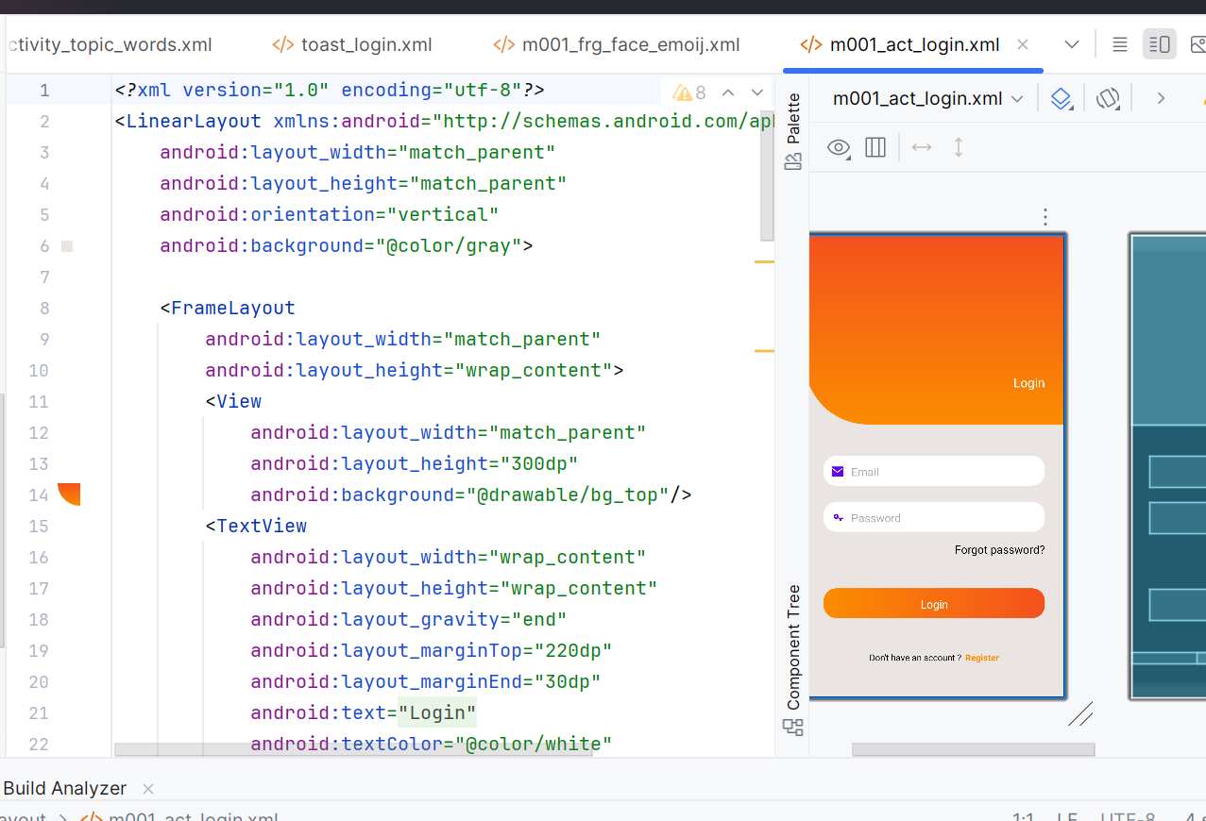
B5. TẠO CUSTOM TOAST KHI ĐĂNG NHẬP
Tạo layout Toast: res/layout/toast_login.xml

<?xml version="1.0" encoding="utf-8"?>
<LinearLayout xmlns:android="http://schemas.android.com/apk/res/android"
android:orientation="horizontal"
android:padding="12dp"
android:background="@drawable/bg_radius"
android:layout_width="wrap_content"
android:layout_height="wrap_content">

<ImageView
android:layout_width="24dp"
android:layout_height="24dp"
android:src="@drawable/ic_key"/>

<TextView
android:id="@+id/tvToast"
android:layout_width="wrap_content"
android:layout_height="wrap_content"
android:layout_marginStart="8dp"
android:textColor="@color/black"
android:textSize="14sp"/>
</LinearLayout>

Tạo Activity: LoginActivity.java

package com.example.lab4ui;

import android.os.Bundle;
import android.view.Gravity;
import android.view.LayoutInflater;
import android.view.View;
import android.widget.EditText;
import android.widget.TextView;
import android.widget.Toast;
import androidx.appcompat.app.AppCompatActivity;

public class LoginActivity extends AppCompatActivity {
private EditText edtEmail, edtPass;

@Override
protected void onCreate(Bundle savedInstanceState) {
super.onCreate(savedInstanceState);
setContentView(R.layout.m001_act_login);

edtEmail = findViewById(R.id.edtEmail);
edtPass = findViewById(R.id.edtPass);

findViewById(R.id.btnLogin).setOnClickListener(v -> showLoginToast());
}

private void showLoginToast() {
String email = edtEmail.getText().toString().trim();
String pass = edtPass.getText().toString().trim();

View toastView = LayoutInflater.from(this).inflate(R.layout.toast_login, null, false);
TextView tv = toastView.findViewById(R.id.tvToast);
tv.setText("Đăng nhập thành công với email: " + email + " và mật khẩu: " + pass);

Toast t = new Toast(this);
t.setView(toastView);
t.setDuration(Toast.LENGTH_SHORT);
t.setGravity(Gravity.BOTTOM, 0, 120);
t.show();
}
}
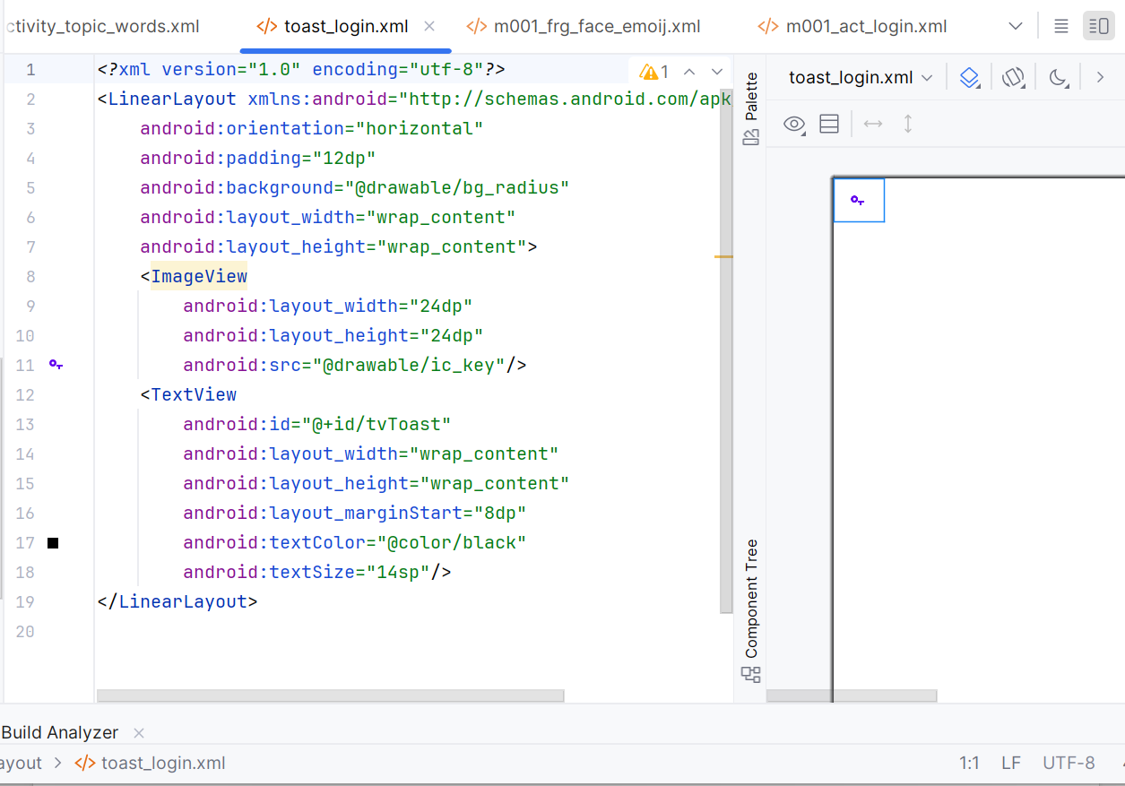
Khai báo trong AndroidManifest.xml

<activity
android:name=".LoginActivity"
android:exported="true">
<intent-filter>
<action android:name="android.intent.action.MAIN" />
<category android:name="android.intent.category.LAUNCHER" />
</intent-filter>
</activity>
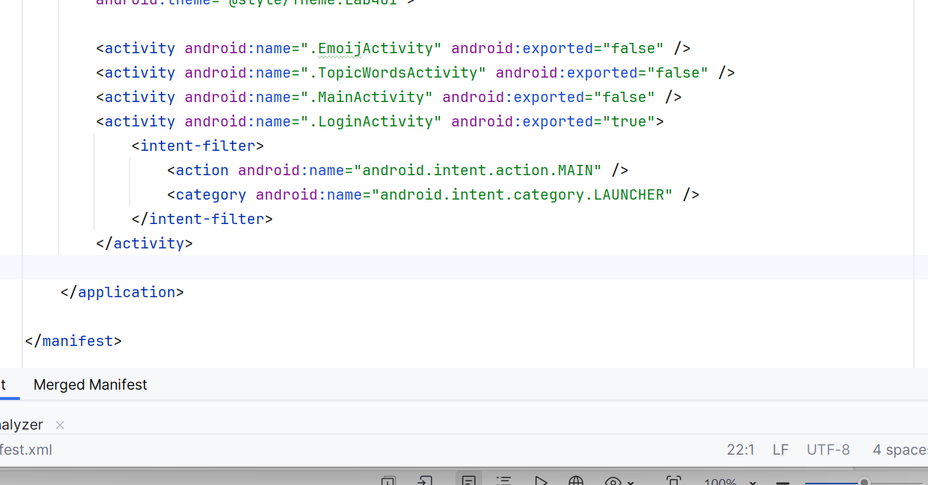
C. LUYỆN TẬP 2 – MENU CHỦ ĐỀ + LISTVIEW TỪ VỰNG

C1. THÊM CHUỖI CHỦ ĐỀ

Thêm vào strings.xml:

<string name="txt_mess">Essentials</string>
<string name="txt_flight">While Traveling</string>
<string name="txt_hospital">Help / Medical</string>
<string name="txt_hotel">At the hotel</string>
<string name="txt_restaurant">At the Restaurant</string>
<string name="txt_coctail">At the Bar</string>
<string name="txt_store">At the Store</string>
<string name="txt_work">Work</string>
<string name="txt_time">Time</string>
<string name="txt_education">Education</string>
<string name="txt_movie">Entertainment</string>

C2. LAYOUT ITEM & ACTIONBAR

item_topic.xml

<?xml version="1.0" encoding="utf-8"?>
<LinearLayout xmlns:android="http://schemas.android.com/apk/res/android"
xmlns:tools="http://schemas.android.com/tools"
android:layout_width="match_parent"
android:layout_height="72dp"
android:orientation="horizontal"
android:paddingHorizontal="10dp"
android:gravity="center_vertical">

<ImageView
android:id="@+id/iv_topic"
android:layout_width="64dp"
android:layout_height="64dp"
android:src="@mipmap/ic_launcher"
tools:ignore="ContentDescription" />

<TextView
android:id="@+id/tv_topic"
android:layout_width="match_parent"
android:layout_height="wrap_content"
android:layout_marginStart="10dp"
android:text="Topic"
android:textColor="@color/black"
android:textSize="18sp" />
</LinearLayout>

actionbar_home.xml

<?xml version="1.0" encoding="utf-8"?>
<LinearLayout xmlns:android="http://schemas.android.com/apk/res/android"
android:layout_width="match_parent"
android:layout_height="56dp"
android:background="@color/purple_500"
android:orientation="horizontal"
android:gravity="center_vertical"
android:paddingHorizontal="10dp">

<TextView
android:layout_width="0dp"
android:layout_height="match_parent"
android:layout_weight="1"
android:gravity="center_vertical"
android:text="@string/app_name"
android:textColor="@color/white"
android:textSize="22sp" />
</LinearLayout>

activity_main.xml

<?xml version="1.0" encoding="utf-8"?>
<LinearLayout xmlns:android="http://schemas.android.com/apk/res/android"
android:orientation="vertical"
android:layout_width="match_parent"
android:layout_height="match_parent">

<include layout="@layout/actionbar_home" />

<LinearLayout
android:id="@+id/ln_main"
android:layout_width="match_parent"
android:layout_height="match_parent"
android:padding="10dp"
android:orientation="vertical"/>
</LinearLayout>

C3. TẠO DANH SÁCH CHỦ ĐỀ ĐỘNG

MainActivity.java

package com.example.lab4ui;

import android.content.Intent;
import android.os.Bundle;
import android.view.LayoutInflater;
import android.view.View;
import android.widget.LinearLayout;
import android.widget.TextView;
import android.widget.Toast;
import androidx.appcompat.app.AppCompatActivity;

public class MainActivity extends AppCompatActivity {
private static final int[] ID_TEXTS = {
R.string.txt_mess, R.string.txt_flight, R.string.txt_hospital,
R.string.txt_hotel, R.string.txt_restaurant, R.string.txt_coctail,
R.string.txt_store, R.string.txt_work, R.string.txt_time,
R.string.txt_education, R.string.txt_movie
};

@Override
protected void onCreate(Bundle savedInstanceState) {
super.onCreate(savedInstanceState);
setContentView(R.layout.activity_main);
initView();
}

private void initView() {
LinearLayout lnMain = findViewById(R.id.ln_main);
lnMain.removeAllViews();

for (int i = 0; i < ID_TEXTS.length; i++) {
final int index = i;
View v = LayoutInflater.from(this).inflate(R.layout.item_topic, lnMain, false);
TextView tvTopic = v.findViewById(R.id.tv_topic);
tvTopic.setText(ID_TEXTS[i]);

v.setOnClickListener(view -> {
// Hiển thị 3 từ mẫu
Toast.makeText(this, sampleWords(index), Toast.LENGTH_SHORT).show();

// Mở màn hình chi tiết
Intent it = new Intent(this, TopicWordsActivity.class);
it.putExtra("topicIndex", index);
startActivity(it);
});

lnMain.addView(v);
}
}

private String sampleWords(int idx) {
String[][] data = sampleData();
int n = Math.min(3, data[idx].length);
StringBuilder sb = new StringBuilder("Từ vựng: ");
for (int i = 0; i < n; i++) {
if (i > 0) sb.append(", ");
sb.append(data[idx][i]);
}
return sb.toString();
}

public static String[][] sampleData() {
return new String[][] {
{"hello","thanks","sorry"},
{"ticket","passport","luggage"},
{"doctor","medicine","clinic"},
{"reception","room","key"},
{"menu","bill","waiter"},
{"cocktail","wine","beer"},
{"price","discount","cashier"},
{"office","meeting","deadline"},
{"hour","minute","second"},
{"school","teacher","student"},
{"movie","cinema","actor"}
};
}
}

activity_topic_words.xml

<?xml version="1.0" encoding="utf-8"?>
<LinearLayout xmlns:android="http://schemas.android.com/apk/res/android"
android:layout_width="match_parent"
android:layout_height="match_parent"
android:orientation="vertical"
android:padding="10dp">

<ListView
android:id="@+id/lvWords"
android:layout_width="match_parent"
android:layout_height="match_parent"/>
</LinearLayout>

TopicWordsActivity.java

package com.example.lab4ui;

import android.os.Bundle;
import android.widget.ArrayAdapter;
import android.widget.ListView;
import androidx.appcompat.app.AppCompatActivity;

public class TopicWordsActivity extends AppCompatActivity {
@Override
protected void onCreate(Bundle savedInstanceState) {
super.onCreate(savedInstanceState);
setContentView(R.layout.activity_topic_words);

int topicIndex = getIntent().getIntExtra("topicIndex", 0);
String[][] data = MainActivity.sampleData();

ListView lv = findViewById(R.id.lvWords);
lv.setAdapter(new ArrayAdapter<>(this, android.R.layout.simple_list_item_1, data[topicIndex]));
}
}

Thêm vào AndroidManifest.xml

<activity android:name=".TopicWordsActivity" android:exported="false"/>

D. LUYỆN TẬP 3 – EMOJI VUI NHỘN (DÙNG FRAGMENT)

D1. CHUẨN BỊ ICON

Tải 9 icon PNG:
ic_angry.png, ic_baffle.png, ..., ic_tire.png
→ Đặt vào res/drawable/

D2. LAYOUT FRAGMENT

m001_frg_face_emoij.xml

<?xml version="1.0" encoding="utf-8"?>
<FrameLayout xmlns:android="http://schemas.android.com/apk/res/android"
android:layout_width="match_parent"
android:layout_height="match_parent">

<LinearLayout
android:layout_width="match_parent"
android:layout_height="match_parent"
android:orientation="vertical"
android:padding="10dp">

<!-- Dòng 1 -->
<LinearLayout android:layout_width="match_parent" android:layout_height="wrap_content" android:gravity="center">
<ImageView android:id="@+id/iv_face1" android:layout_width="100dp" android:layout_height="100dp"
android:background="@drawable/bg_radius" android:padding="10dp" android:src="@drawable/ic_angry"/>
<ImageView android:id="@+id/iv_face2" android:layout_width="100dp" android:layout_height="100dp"
android:layout_marginStart="10dp" android:background="@drawable/bg_radius" android:padding="10dp" android:src="@drawable/ic_baffle"/>
<ImageView android:id="@+id/iv_face3" android:layout_width="100dp" android:layout_height="100dp"
android:layout_marginStart="10dp" android:background="@drawable/bg_radius" android:padding="10dp" android:src="@drawable/ic_beauty"/>
</LinearLayout>

<!-- Dòng 2 & 3 tương tự... -->
<!-- (Copy 3 khối LinearLayout như mẫu trên) -->

<TextView
android:id="@+id/btnRandom"
android:layout_width="match_parent"
android:layout_height="48dp"
android:layout_marginTop="16dp"
android:gravity="center"
android:text="Random 3 Icon"
android:textSize="16sp"
android:textColor="@color/white"
android:background="@color/purple_500"/>
</LinearLayout>
</FrameLayout>

D3. FRAGMENT & ACTIVITY

FragmentFaceEmoij.java

package com.example.lab4ui;

import android.graphics.drawable.Drawable;
import android.os.Bundle;
import android.view.LayoutInflater;
import android.view.View;
import android.view.ViewGroup;
import android.widget.ImageView;
import android.widget.Toast;
import androidx.fragment.app.Fragment;
import java.util.Random;

public class FragmentFaceEmoij extends Fragment implements View.OnClickListener {
private static final int[] IDs = {
R.id.iv_face1, R.id.iv_face2, R.id.iv_face3,
R.id.iv_face4, R.id.iv_face5, R.id.iv_face6,
R.id.iv_face7, R.id.iv_face8, R.id.iv_face9
};

@Override
public View onCreateView(LayoutInflater inflater, ViewGroup container, Bundle savedInstanceState) {
View root = inflater.inflate(R.layout.m001_frg_face_emoij, container, false);
for (int id : IDs) root.findViewById(id).setOnClickListener(this);
root.findViewById(R.id.btnRandom).setOnClickListener(v -> randomize(root));
return root;
}

@Override
public void onClick(View v) {
ImageView iv = (ImageView) v;
showToast(iv.getDrawable());
}

private void showToast(Drawable d) {
if (getContext() == null) return;
Toast t = new Toast(getContext());
ImageView iv = new ImageView(getContext());
iv.setImageDrawable(d);
t.setView(iv);
t.setDuration(Toast.LENGTH_SHORT);
t.show();
}

private void randomize(View root) {
int[] drawables = {R.drawable.ic_angry, R.drawable.ic_baffle, R.drawable.ic_beauty,
R.drawable.ic_boss, R.drawable.ic_choler, R.drawable.ic_dribble,
R.drawable.ic_look_down, R.drawable.ic_sure, R.drawable.ic_tire};
ImageView[] targets = {
root.findViewById(R.id.iv_face1),
root.findViewById(R.id.iv_face2),
root.findViewById(R.id.iv_face3)
};
Random r = new Random();
for (ImageView iv : targets) {
iv.setImageResource(drawables[r.nextInt(drawables.length)]);
}
}
}

activity_emoij.xml

<?xml version="1.0" encoding="utf-8"?>
<FrameLayout xmlns:android="http://schemas.android.com/apk/res/android"
android:layout_width="match_parent"
android:layout_height="match_parent">
<fragment
android:id="@+id/frg_face_emoij"
class="com.example.lab4ui.FragmentFaceEmoij"
android:layout_width="match_parent"
android:layout_height="match_parent"/>
</FrameLayout>

EmoijActivity.java

package com.example.lab4ui;

import android.os.Bundle;
import androidx.appcompat.app.AppCompatActivity;

public class EmoijActivity extends AppCompatActivity {
@Override
protected void onCreate(Bundle savedInstanceState) {
super.onCreate(savedInstanceState);
setContentView(R.layout.activity_emoij);
}
}

Thêm vào AndroidManifest.xml

<activity android:name=".EmoijActivity" android:exported="false"/>

HOÀN TẤT!

Bạn đã có một app đẹp, mượt, chuyên nghiệp với:

- Login có Custom Toast
- Menu chủ đề từ vựng động
- Màn Emoji vui nhộn dùng Fragment
- Giao diện bo góc, gradient, vector chuẩn Material

